Instructions to Connect to Galileo from PC via Ethernet

1) Connect Galileo and Computer to Ethernet.

2) Connect Galileo to Computer via COM (USB).

3) Find COM # based on „Device Manager‟.

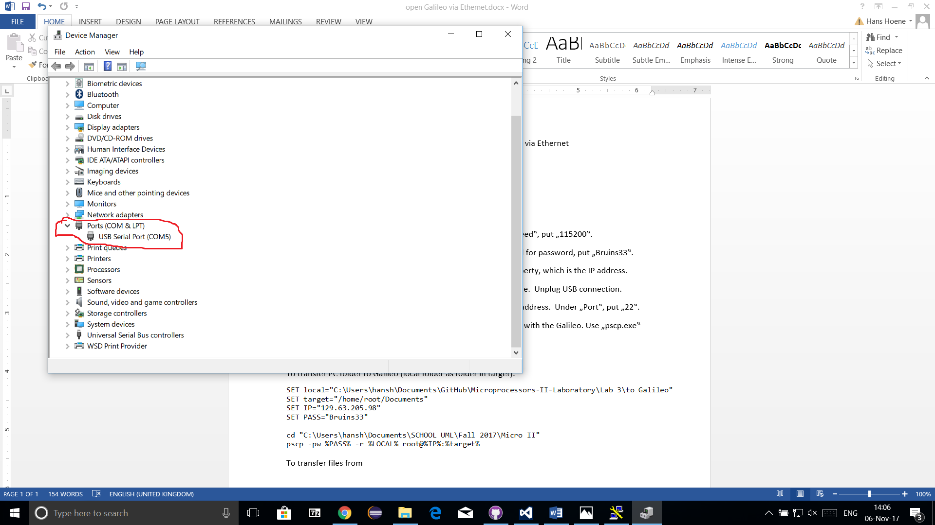

4) Open „putty.exe‟.

5) Go to „Serial‟ tab. Under „Serial line‟, put COM #. Under „Speed‟, put „115200‟.

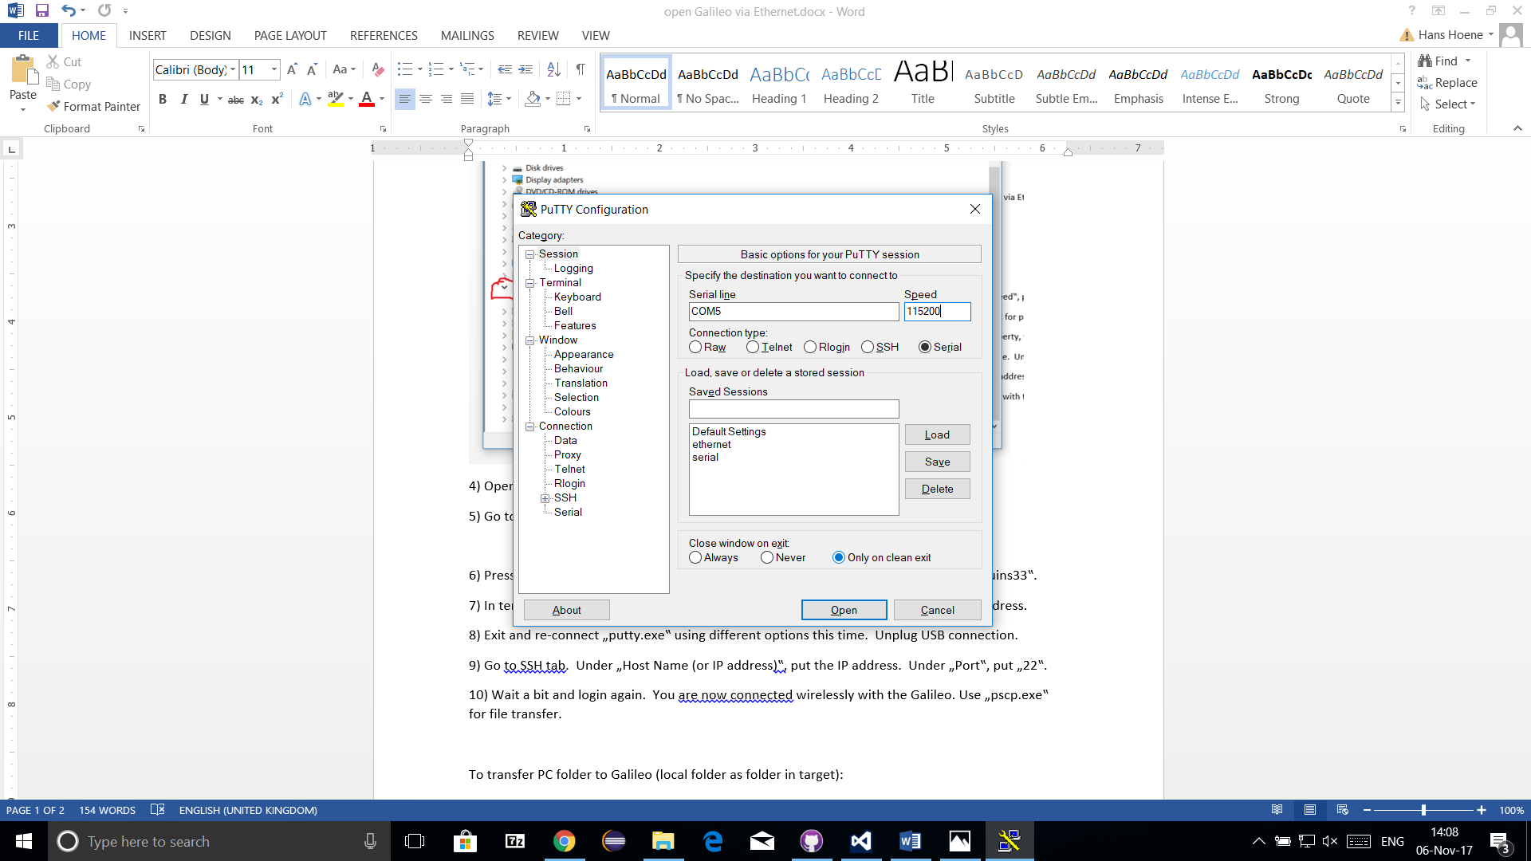

6) Press enter to begin logging in to terminal. Login as „root‟ and for password, put „Bruins33‟.

7) In terminal, type „/sbin/ifconfig‟ and read the „inet addr‟ property, which is the IP address.

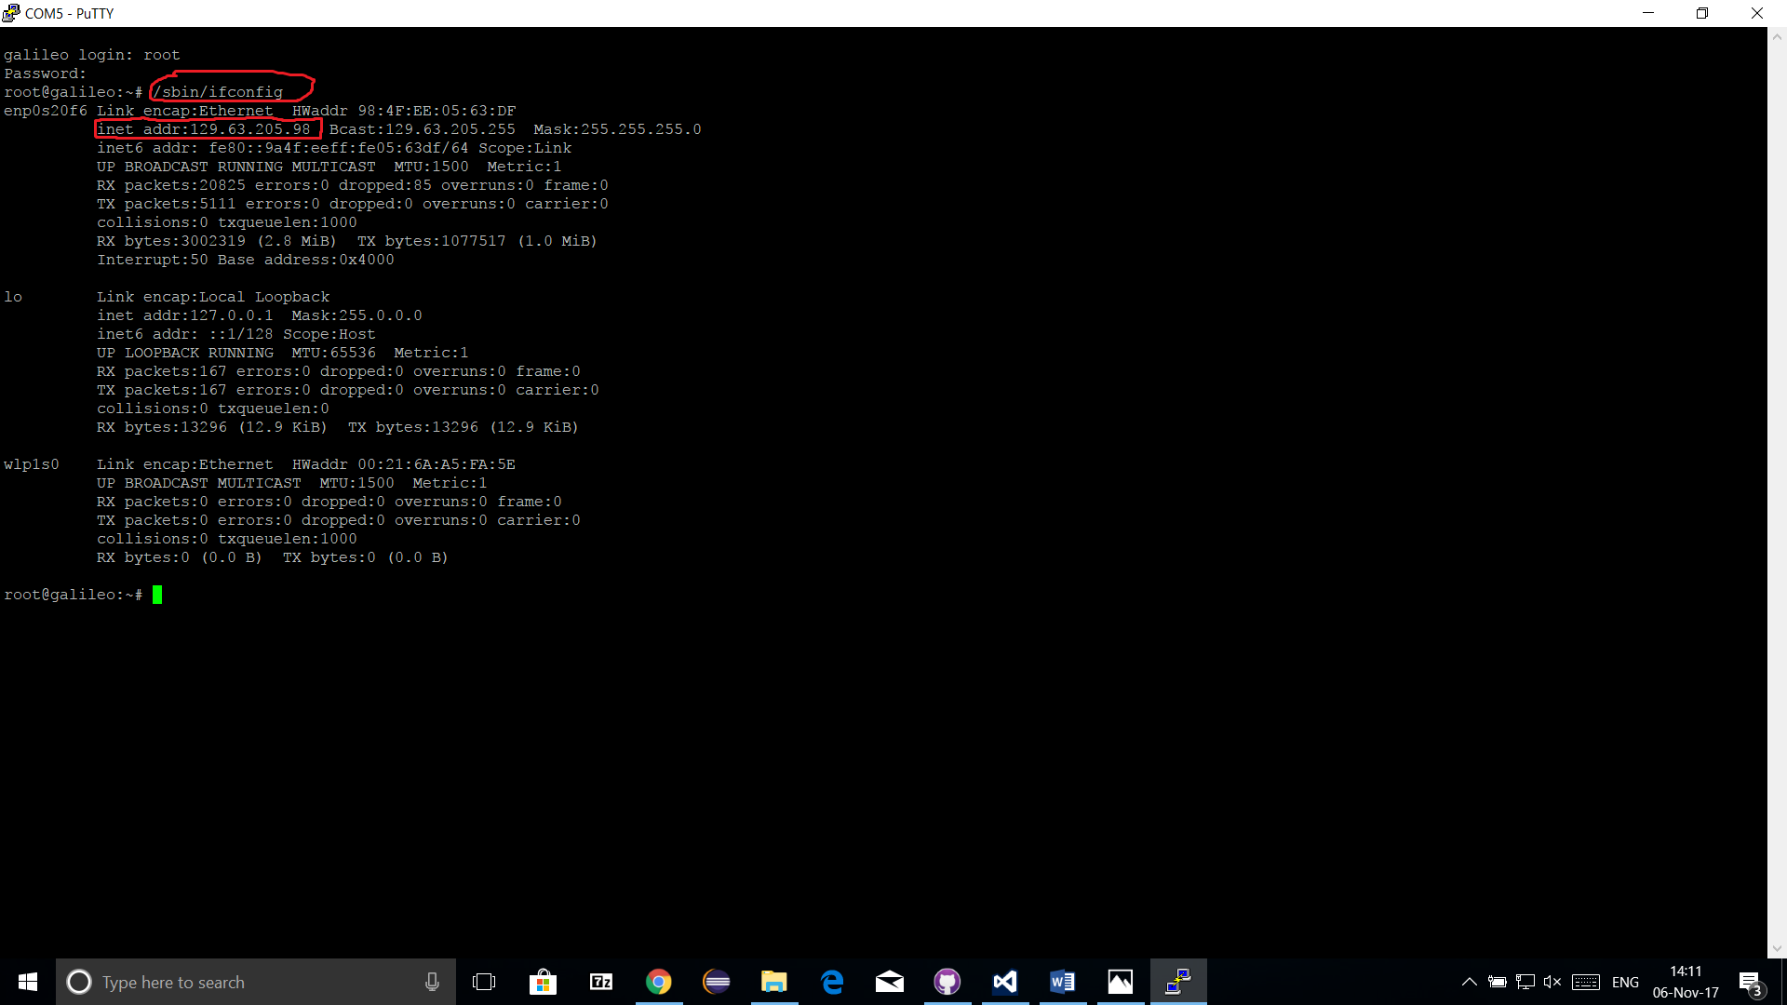

8) Exit and re-connect „putty.exe‟ using different options this time. Unplug USB connection.

9) Go to SSH tab. Under „Host Name (or IP address)‟, put the IP address. Under „Port‟, put „22‟.

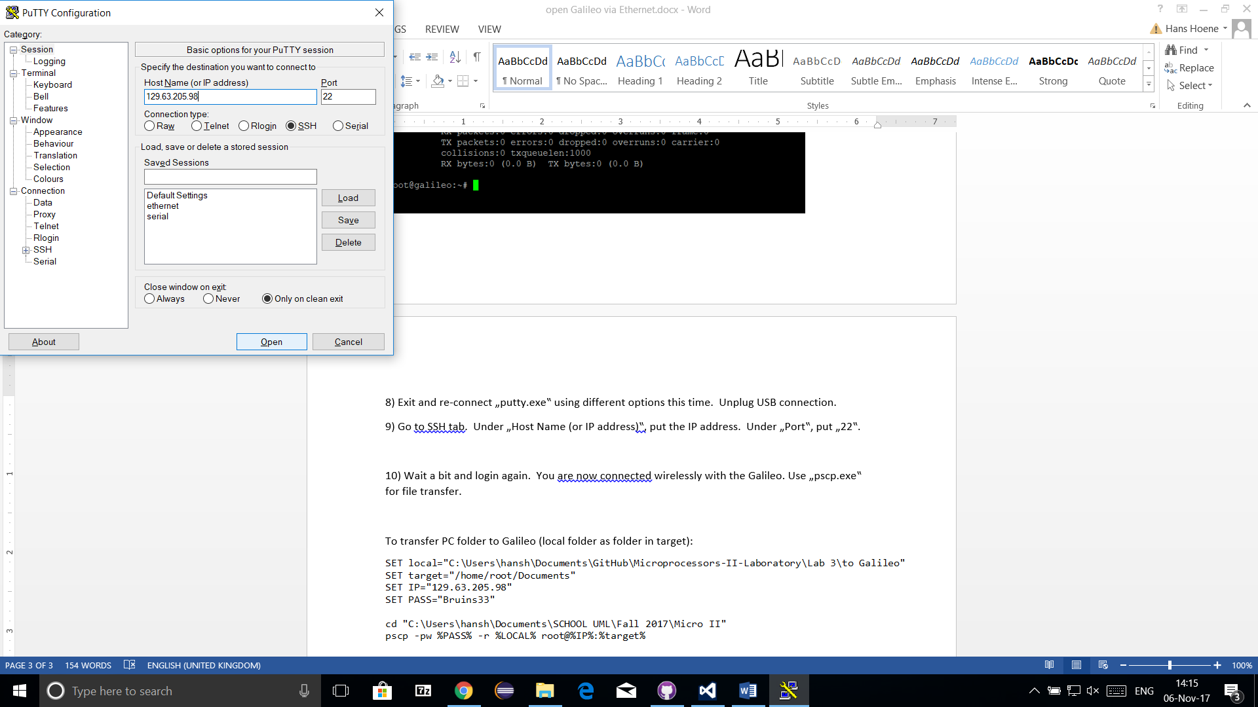

10) Wait a bit and login again. You are now connected wirelessly with the Galileo. Use „pscp.exe‟ for file transfer.

To transfer PC files to Galileo:



To transfer Galileo files to PC:

